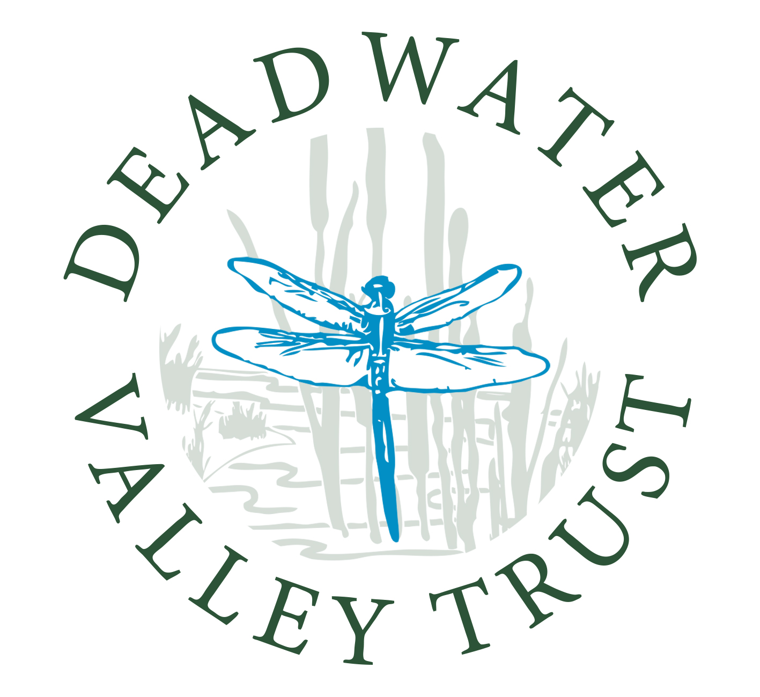

The Deadwater Valley Trust is an environmental charity which manages the
Deadwater Valley Local Nature Reserve and Bordon Inclosure & Hogmoor Inclosure SANGs
in Whitehill & Bordon.

“Friends of the Deadwater & Hogmoor”
Membership Form May 2024 to May2025

Name: ______________________________________ Title: _________

Address: ___________________________________________________

_____________________________________ Postcode: ____________

Telephone Number(s): ________________________________________

E-mail Address: _____________________________________________

Please note that in order to save paper we will send out the majority of our communication via e-mail.*

Subscription: Minimum £12.00 per member per year. If joining part way through the year the subscription shall be the £1 per month to the total number of months remaining in the subscription year.
Please pay in cash to the Ranger team or pay by bank transfer to:
sort code 30-93-20; account no. 01132672 ref Friends Of

Membership of ‘The Friends of the Deadwater’ entitles you to receive copies of the Deadwater Dispatch, invitations to our various fundraising events, invitation to our DVTalks and to elect one member to represent the ‘Friends’ on the Trust’s Board of Trustees

Your membership provides welcome support for the Trust’s work

*Data Protection Act
Your details will be securely stored on paper and on the Deadwater Valley Trust computer. Your details will only be used by the Deadwater Valley Trust in connection with its publicity, events and newsletter. At no time will these details be passed on to any third parties. Receipt of your subscription for the coming year will keep your updated details on record for that year. If subscription is not renewed your details shall be removed.

Charitable Incorporated Organisation No. 1160737
Deadwater Valley Trust, Phoenix Centre, Station Road, Bordon, Hampshire, GU35 0LR
T: 01420 479070 E: rangers@deadwatervalleytrust.co.uk W: deadwatervalleytrust.co.uk

